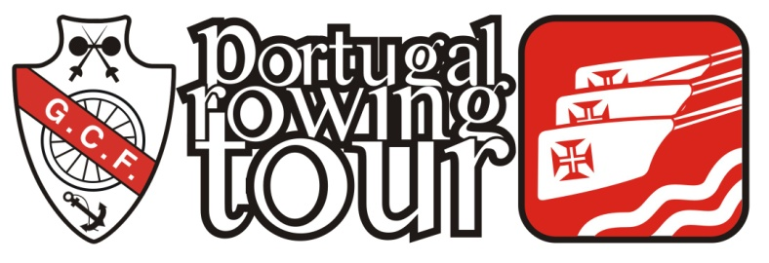
MONDEGO 2017
ENTRY FORM

Country and club:
Name of participant:
Address:
Birth date |  | Male/Female: | Height: (meter)
E-mail address:
Telephone (incl. country code):
Member of Rowing Club:
Previous participation in tours:
Signature of participant:

The participants agree with his signature to the following:
- Candidates shall possess good knowledge and ability of rowing techniques, both for sculling and oars rowing.
- Candidates shall be in good health and have the physical condition necessary for rowing the distances proposed, and shall be able to handle dangerous situations on their own and not depend on the help from others.
- Candidates shall be capable of swimming a distance of at least 300-meter.
- Each participant shall carry with them, a life saving jacket as recommended by their national authorities.

